13) Write a C program to implement Queue operations such as ENQUEUE, DEQUEUE and Display

PROGRAM:

#include <stdio.h>

#include <stdlib.h>

#define SIZE 5

int queue[SIZE];

int front = -1, rear = -1;

void enqueue(int value) {

if (rear == SIZE - 1)

printf("Queue is full\n");

else {

if (front == -1)

front = 0;

rear++;

queue[rear] = value;

}

}

void dequeue() {

if (front == -1 || front > rear)

printf("Queue is empty\n");

else {

printf("Deleted element: %d\n", queue[front]);

front++;

}

}

void display() {

if (front == -1)

printf("Queue is empty\n");

else {

printf("Queue elements: ");

for (int i = front; i <= rear; i++)

printf("%d ", queue[i]);

printf("\n");

}

}

int main() {

enqueue(10);

enqueue(20);

enqueue(30);

display();

dequeue();

display();

return 0;

}

INPUT:

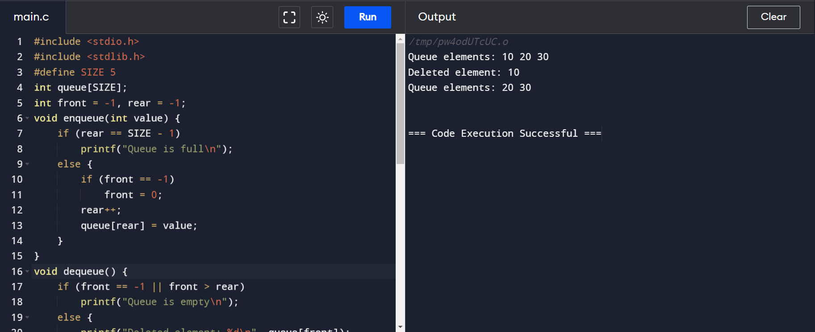

OUTPUT:

